SHARING STORIES ACTION PLAN
Use the table below to plan how you are going to share the messages and ideas from your stories.

LEARNING
What are the key messages and ideas from your stories?

PURPOSE  What change are you trying to make from your stories? |  | AUDIENCE  Who can help to make this change? | SHARING METHOD  How will you share the stories with these people?
TASKS  What do you need to do? | 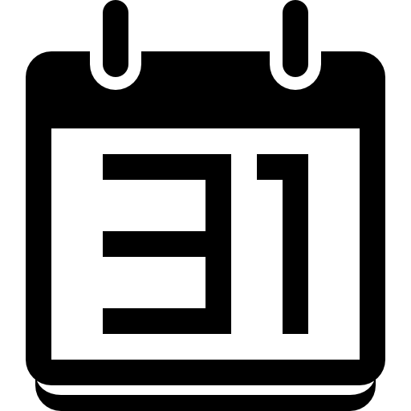  DATES  When does it need to be done? | PEOPLE  Who will do it?

